**Monthly electricity production in Australia**

By Matt Korzec

* **Data Set**

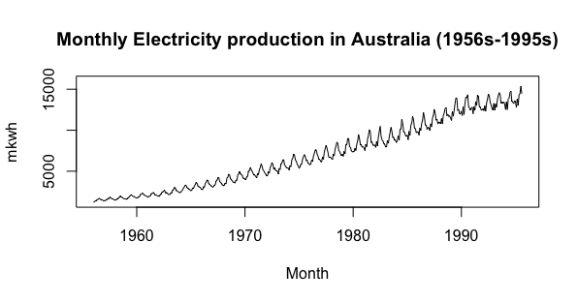

Time Range: 1956/1/1 - 1995/8/1

Sample Size: 476

Variables: Month and Million Kilowatt Hour

* **Training Data**

Training data: 450 & Test data: 26

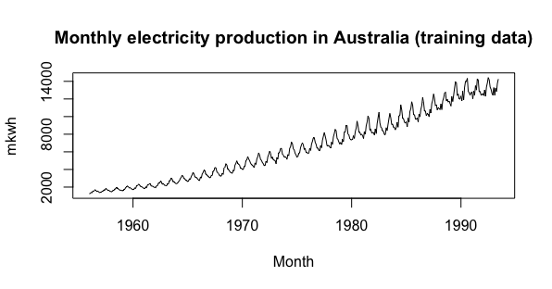

=> upward trend with increasing variance (fan shape)

* **Log transformation**

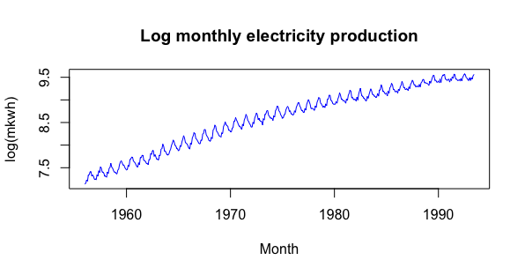

=> constant variance, increasing trend

* **Check for weakly stationary**

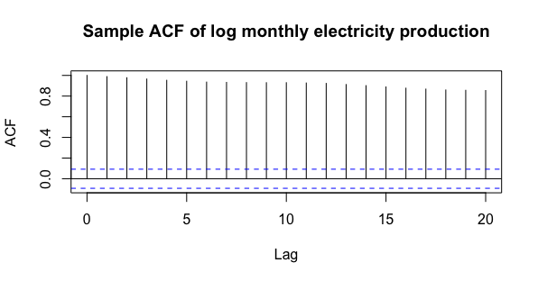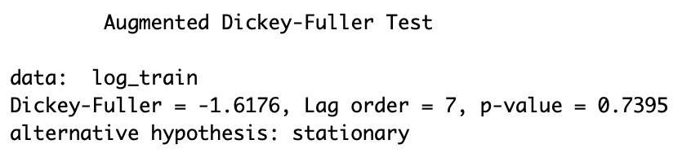

=>sample ACF dies down slowly

=>unit-root non-stationary

* **Lag-1 differencing**

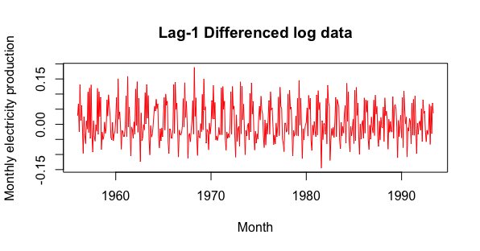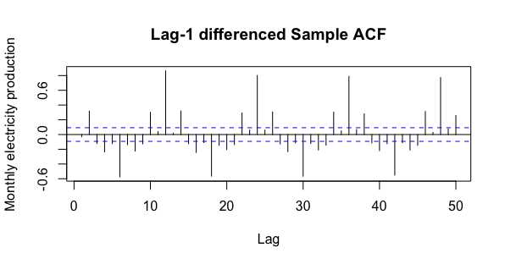

=>sample ACF dies down quickly

=>unit-root non-stationary removed

=> sample ACF dies down at lags with a period of 12

=> the period is 12

* **Lag-12 Seasonal differencing to remove seasonal non-stationary**

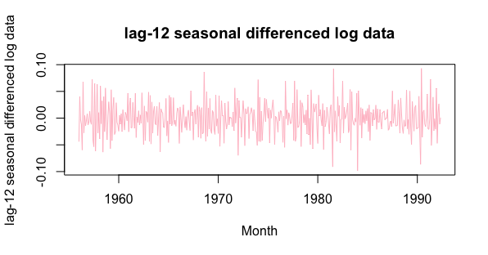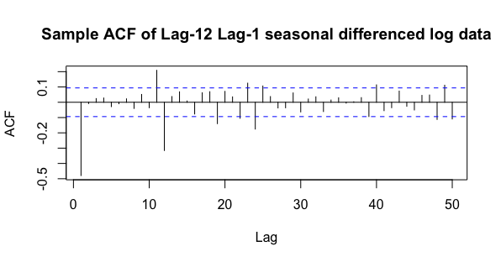

=> sample ACF cuts off quickly

=> seasonal non-stationary has been removed

=> weakly stationary

* **Test the mean of the resulting data to see if a intercept term is needed in the model**

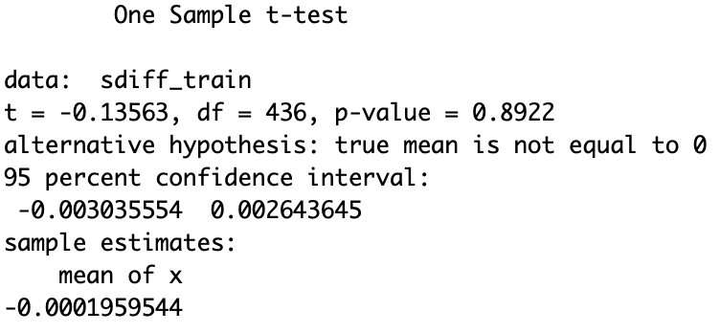

=> fail to reject the null hypothesis

=> the mean is equal to 0

=> exclude the intercept in the model

* **Model Selection**

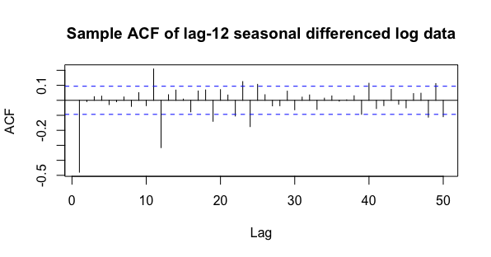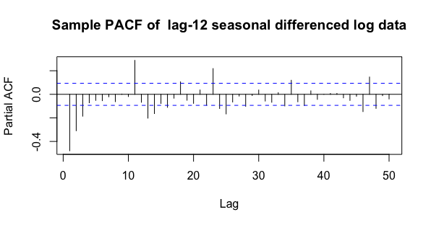

=> Sample ACF cuts off at lag-24;

Sample PACF dies down;

=> MA(2)_12 should be chosen

=> with in the first period, sample ACF cuts off at lag-1

=> MA(1) needed

=> we will compare several other models with SARIMA(0,1,1) x

(0,1,2)_12

Model1: SARIMA(0,1,1) x (0,1,2)12  Model

Model2: SARIMA(0,1,1) x (0,1,1)12  Model

Model3: SARIMA(0,1,1) x (1,1,0)12  Model

Model4: SARIMA(0,1,1) x (1,1,1)12  Model

* **Model Comparison**

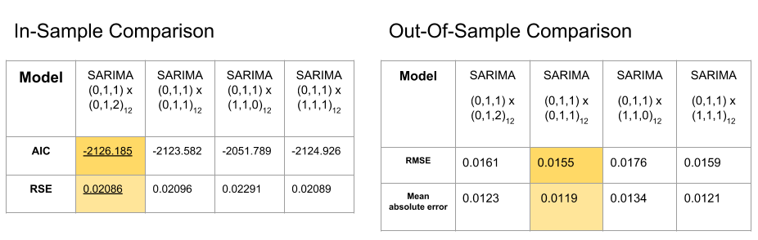

=> The four models are very close to each other. To keep our final model simple,

we finally chose SARIMA(0, 1, 1) x (0, 1, 1)_12 model.

* **Final Model: SARIMA(0,1,1) x (0,1,1)12**

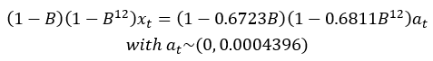

* **Check Adequacy of the model**

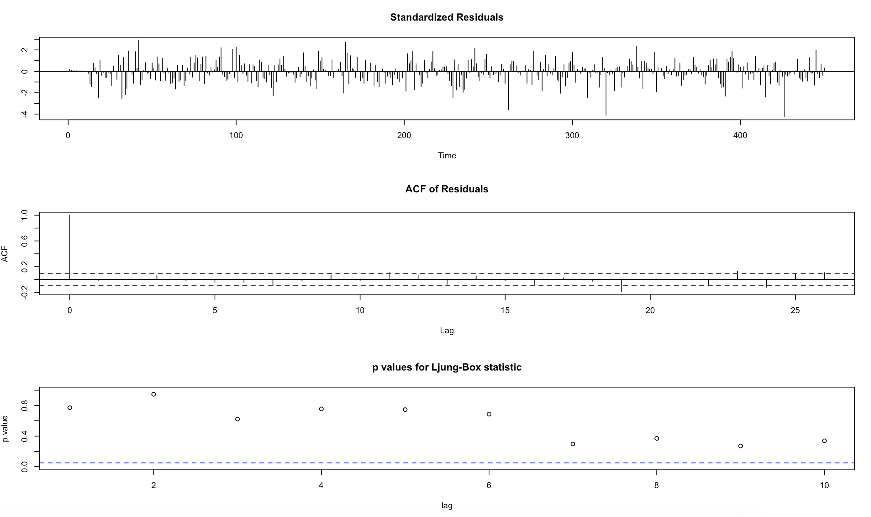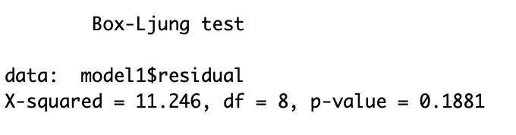

=> The model is adequate.

* **Forecasting**

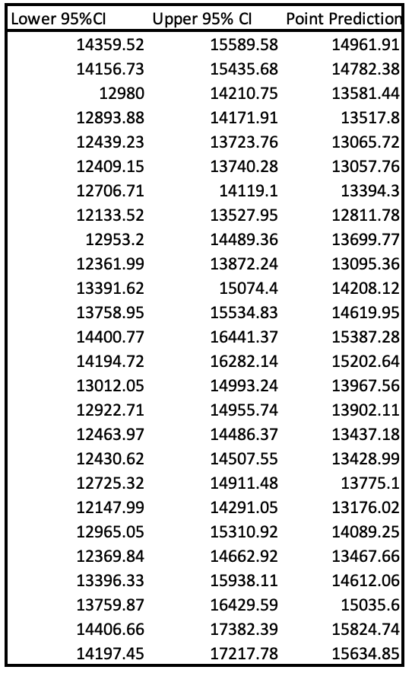 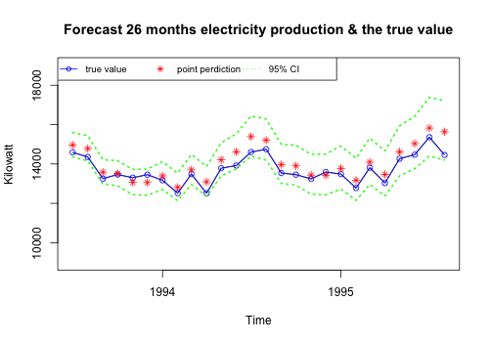

=> all testing data fall in the prediction interval with 95% confidence interval

=> the model works fine.